**Stakeholder Toolkit**

**Are you Prepared for the 2024 Hurricane Season?**

|  |
| --- |
| Hurricane season is quickly approaching, officially starting June 1 and lasting until November 30. Researchers are predicting that the 2024 hurricane season is going to be extremely active. The National Oceanic and Atmospheric Association (NOAA) [predicts above-normal hurricane activity](https://www.noaa.gov/news-release/noaa-predicts-above-normal-2024-atlantic-hurricane-season) in 2024, with 17 to 25 named storms.  USDA encourages producers to prepare and protect their family and agricultural operations. To further amplify disaster preparedness for hurricanes and tropical storms, I am sharing a social media toolkit and corresponding graphic images for use as you deem appropriate.  **We need your help to spread the word to eligible farmers and livestock producers.** This toolkit includes:   * Suggested Newsletter * Social Media Suggestions * Graphics (attached)   Other useful resources for farmers and livestock producers include:   * [Disaster Assistance Discovery Tool](https://www.farmers.gov/recover/disaster-tool) - Learn about USDA disaster assistance programs that might be right for you by completing five simple steps. * [Disaster Assistance Programs Brochure](https://www.farmers.gov/sites/default/files/2022-07/farmersgov-disaster-assistance-brochure-07-21-2022.pdf) - A snapshot of all available FSA, NRCS and RMA disaster services and products * FarmRaise Hub - Resources and decision tools available to agricultural producers and cooperators who help producers to access USDA disaster assistance, farm loans and other federal farm programs. * [Loan Assistance Tool](https://lat.fpac.usda.gov/) - Check your eligibility for FSA loans, discover the various FSA loan products, learn about documentation requirements, and follow easy to understand instructions when completing the loan application forms. * [Hurricane](https://www.farmers.gov/protection-recovery/hurricane) Farmers.gov Webpage - Find programs and resources that can help prepare for and recover from hurricanes. |
|  |

**Suggested Newsletter**

Hurricane season is quickly approaching, officially starting June 1 and lasting until November 30. Researchers are predicting that the 2024 hurricane season is going to be extremely active. The National Oceanic and Atmospheric Association (NOAA) [predicts above-normal hurricane activity](https://www.noaa.gov/news-release/noaa-predicts-above-normal-2024-atlantic-hurricane-season) in 2024, with 17 to 25 named storms.

USDA encourages producers to prepare and protect their family and agricultural operations.

1. **Develop an Emergency Plan**- Ensure your household and employees know your hurricane plan, including meeting points, emergency contact lists, and alternate evacuation routes in case infrastructure is damaged.
2. **Remove Debris and Secure Large Objects**- Clean out culverts, ditches, and other drainage areas, especially before and during peak hurricane season to reduce water damage. Most injuries to animals, people, or structures during a hurricane are caused by flying objects. To lessen the risk, minimize the presence of equipment, supplies, and debris that may become airborne during high winds or encountered in floodwaters.
3. **Secure Important Records and Documents** - Pre- and post-hurricane documentation is extremely important for insurance compensation and recovery assistance. You’ll want to have thorough records of damages and losses sustained on your farm as well as documentation of your cleanup and recovery efforts.
   * It is critical to document inventory of farm buildings, vehicles, equipment, and livestock before a disaster occurs. Take photos, videos, or make written lists with descriptions. Keep copies of this inventory in multiple places: computer, off-site in a safe location, and on a cloud-based server where information is transmitted and saved weekly.
4. **Know Your Insurance Options** - Regularly review your insurance policies with your agent to be sure you have adequate coverage, including flood insurance, for your facilities, vehicles, farm buildings, crops and livestock. Note, there are limitations on how soon insurance coverage will take effect. Generally, insurance policies will not cover damage if the policy was not in place before a disaster.
5. **Gather Supplies**- Have drinking water, canned food, a generator, batteries, a flashlight, and fuel available in case you lose power. For widespread outages, credit and debit cards may not work, so have cash handy.
6. **Access Real-time Emergency Information** - Download the Federal Emergency Management Agency smartphone app for free on the App Store and Google Play for safety tips on what to do before, during, and after disasters. Subscribe to our [text message and email service](https://www.farmers.gov/working-with-us/stay-connected) to receive real-time, local operational and recovery information from the Farm Service Agency, Natural Resources Conservation Service and Risk Management Agency.

On farmers.gov, the [Hurricane Webpage](https://www.farmers.gov/protection-recovery/hurricane), [Disaster Assistance Discovery Tool](https://www.farmers.gov/node/28989), [Disaster-at-a-Glance fact sheet](https://www.farmers.gov/sites/default/files/2022-07/farmersgov-disaster-assistance-brochure-07-21-2022.pdf), and [Loan Assistance Tool](https://lat.fpac.usda.gov/) can help producers and landowners determine program or loan options. For assistance with a crop insurance claim, producers and landowners should contact their [crop insurance agent](https://www.rma.usda.gov/en/Information-Tools/Agent-Locator-Page). For FSA and NRCS programs, they should contact their local [USDA Service Center](http://www.farmers.gov/service-center-locator).

**Stakeholder Social Media and Infographics**

**Twitter**

Hurricane season is quickly approaching, officially starting June 1 and lasting until Nov 30. Here are a few steps you can take now to help protect your family and ag operation in the event of a hurricane. [Hurricane Preparation and Recovery Resources | Farmers.gov](https://www.farmers.gov/protection-recovery/hurricane)

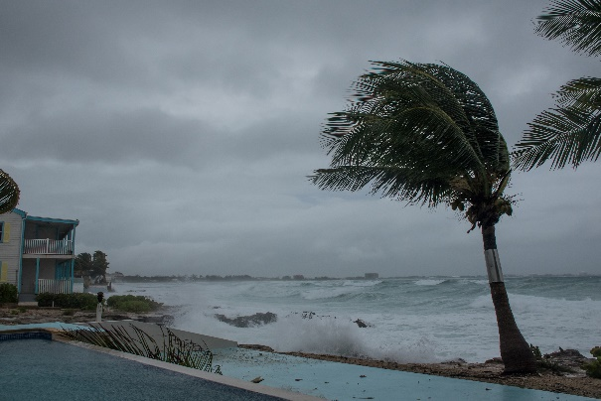

Are you prepared for the 2024 hurricane season? Here are several precautions you can take to help protect your family and ag operation. [Hurricane Preparation and Recovery Resources | Farmers.gov](https://www.farmers.gov/protection-recovery/hurricane)

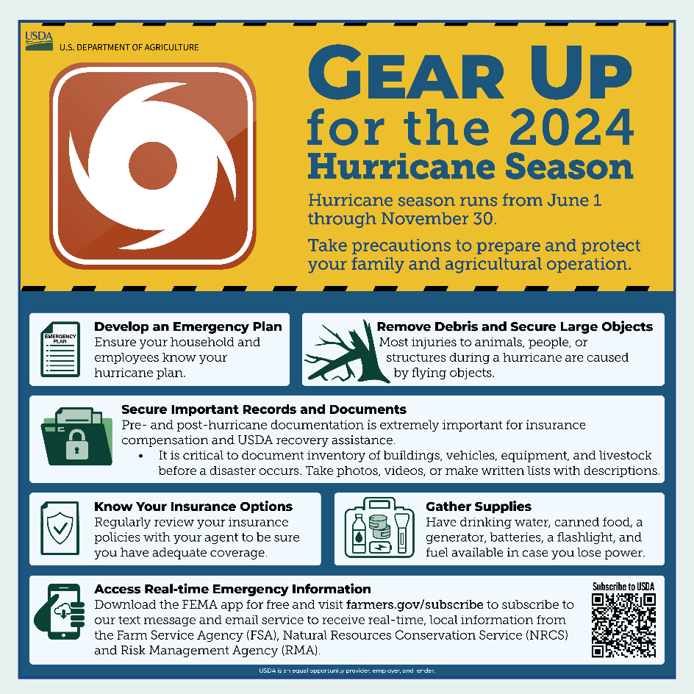

**Instagram Story or Facebook Story**

Link to <https://www.farmers.gov/protection-recovery/hurricane>